Functional English

**Social Situations**

**Situation: Introducing Yourself**

*Objective: To practice introducing yourself to a new classmate.*

Instructions:

1. Students are paired up with a classmate they do not know.
2. Each student takes turns introducing themselves and asking questions to get to know their partner.

**Example Dialogue:**

Aiman: Hi, my name is Aiman. What's your name?

Shayan: Hi, Aiman. My name is Shayan.

Aiman: Nice to meet you, Shayan. Where are you from?

Shayan: I'm originally from Tehran, Iran. How about you?

Aiman: I'm from Lahore, Pakistan. What do you like to do in your free time, Shayan?

Shayan: I enjoy playing sports, especially basketball. How about you?

Aiman: I like reading books and watching movies in my free time. What kind of books do you like to read?

(Shayan and Aiman continue to ask questions and get to know each other.)

**Situation: Making Plans**

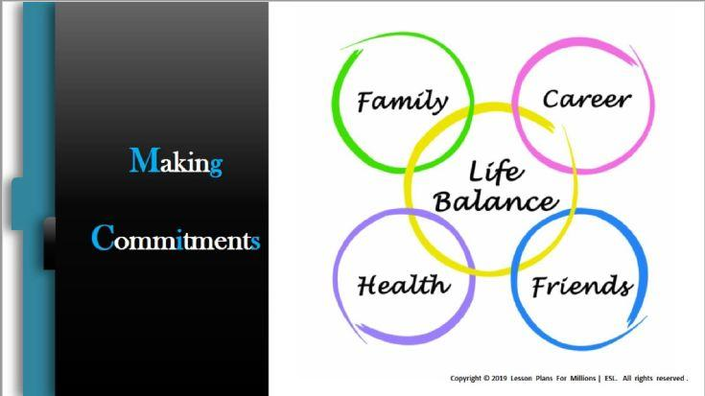Objective: To practice making plans with a partner or friend.

Instructions:

**Example Dialogue:**

Fizza: Hi, Hibba. Do you want to do something fun this weekend?

Hibba: Yeah, that sounds great. Do you have any ideas?

Fizza: How about going to the park and having a picnic?

Hibba: Oh, that's a good idea. What kind of food should we bring?

Fizza: We could bring sandwiches, fruit, and some chips.

Hibba: Sounds good to me. What time do you want to meet?

Fizza: How about we meet at the park at noon?

Hibba: Okay, that works for me. Is there anything else we need to bring?

Fizza: We should bring a blanket to sit on and maybe some games to play.

Hibba: Okay, I'll bring a deck of cards. What kind of games do you like to play?

(Fizza and Hibba continue to discuss the plan and make final arrangements.)

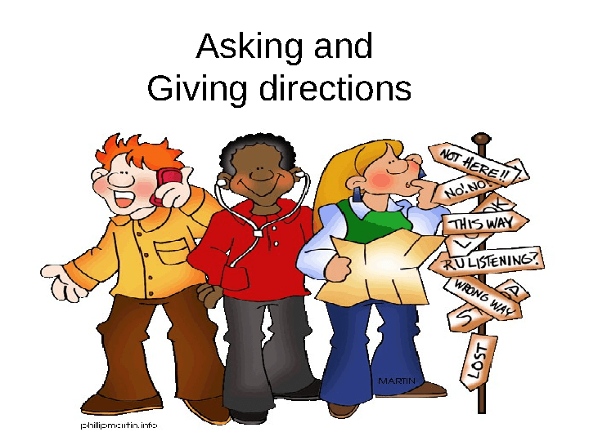**Situation: Asking for Directions**

Objective: To practice asking for directions in English.

Instructions:

**Example Dialogue:**

Asif: Excuse me, do you know where the nearest post office is?

Chad: Sure, the post office is on Main Street. Do you know where Main Street is?

Asif: No, I don't. Can you give me directions?

Chad: Sure. First, you need to turn left at the intersection here, and then continue straight until you see a big red building. That's the post office.

Asif: Okay, got it. How far is it from here?

Chad: It's about a 10-minute walk from here. Do you need any other help with directions?

Asif: No, that's all. Thank you so much for your help.

Chad: You're welcome. Have a good day.

Asif: You too.

Teacher: Great job, everyone. Let's move on to the next activity.

1. Greetings and introductions
2. Making small talk
3. Ordering food and drinks in a restaurant or café
4. Asking for directions and giving directions
5. Making travel arrangements (booking flights, hotels, etc.)
6. Shopping and bargaining
7. Discussing hobbies and interests
8. Talking about current events and news
9. Making phone calls (e.g. calling to schedule an appointment or to inquire about a service)
10. Giving and receiving advice
11. Making plans and arranging meetings with friends or colleagues
12. Job interviews and discussing career goals
13. Expressing opinions and preferences
14. Apologizing and making apologies
15. Giving and receiving compliments
16. Asking for help and offering help to others
17. Discussing cultural differences and customs
18. Talking about family and relationships
19. Discussing health and well-being
20. Talking about education and academic goals.

**Activity – Drawing shapes through discussion**

**Being polite in conversations with native speakers is important for several reasons:**

1. It shows respect: When you use polite language and manners, you demonstrate that you respect the other person and their culture.
2. It builds rapport: Politeness can help to create a positive and friendly atmosphere, making it easier to establish a connection with the native speaker.
3. It helps with communication: Being polite can help to avoid misunderstandings and promote clearer communication.

To be polite in conversations with native speakers, you can follow these tips:

1. Use appropriate greetings: Depending on the situation, you might use "hello", "hi", "good morning", "good afternoon", or "good evening".
2. Use honorifics and titles: In many cultures, it is important to use titles like "Mr.", "Ms.", or "Professor" when addressing someone.
3. Use please and thank you: Using these simple words can make a big difference in showing politeness and respect.
4. Avoid interrupting: Wait for the other person to finish speaking before responding.
5. Use appropriate tone and body language: Use a friendly and respectful tone of voice, and maintain eye contact and good posture.
6. Apologize when necessary: If you make a mistake or cause offense, apologize sincerely and take responsibility for your actions.

Overall, being polite in conversations with native speakers can help to create positive relationships and promote effective communication.

**Situation: You accidentally spilled coffee on your colleague's shirt.**

You: Oh no, I'm so sorry! I didn't mean to spill coffee on your shirt. Please forgive me.

Colleague: It's okay, accidents happen. Thanks for apologizing.

You: Is there anything I can do to help? Can I get you a new shirt or something?

Colleague: No, it's fine. I have a spare shirt in my bag. But thank you for offering.

You: Okay, let me know if you need anything else. And again, I'm really sorry for the spill.

In this dialogue, you can see the use of "sorry" and "please forgive me" as ways to apologize for the mistake. Additionally, the offer to help and the use of polite language ("Is there anything I can do to help?") shows a willingness to make amends and take responsibility for the mistake. The colleague's response of accepting the apology and thanking you shows the importance of forgiveness and moving on from the mistake. Overall, this dialogue demonstrates how politeness and respect can help to diffuse a potentially awkward or uncomfortable situation.

**Different Levels of Politeness:**

Situation: You need to ask your boss for time off work.

Level 1 Politeness: You: Hey boss, can I have Friday off work?

This is a polite request, but it could be improved by adding more formal language.

Level 2 Politeness: You: Excuse me boss, would it be possible for me to request time off work this Friday?

This level of politeness is more formal and shows respect for the boss's position. However, it could be improved by adding more polite language, like "thank you" and "please".

Level 3 Politeness: You: Good morning, boss. I hope you're doing well. I was wondering if it would be possible for me to request time off work this Friday. I understand if this is not possible, but I would be very grateful for your help.

This level of politeness is more formal and respectful, using polite greetings and showing gratitude for the boss's help. It also acknowledges the possibility that the request may not be granted, which shows an understanding of the boss's needs and priorities.

**Face-Saving**

Face-saving in conversation refers to the practice of avoiding actions or language that may cause embarrassment or shame to oneself or others. Being indirect can be a way to save face by avoiding direct confrontation or criticism.

Here's an example dialogue that illustrates face-saving and indirect language:

**Situation:** You are a manager who needs to give constructive feedback to an employee about their work performance.

**Direct Approach:** Manager: Your work has been consistently below the expected standards. You need to improve your performance or face consequences.

This approach may be too direct and confrontational, causing the employee to feel embarrassed or defensive.

**Indirect Approach:** Manager: I've noticed that there have been some challenges with your work lately. Are there any areas where you feel you may need additional support or training?

This approach is more indirect, and allows the employee to save face by not pointing out specific areas where they are struggling. It also offers support and guidance instead of criticism, which can help to avoid potential conflict.

**Situation: You are planning a party and want to ask your friend for help.**

**You:** Hi, I wonder if you could help me with something. I'm planning a party next week and I could really use some assistance with the decorations.

**Friend:** Sure, I'd be happy to help! What do you need me to do?

**You:** That's great, thank you so much! Could you bring some balloons and streamers, and maybe help me set them up on the day of the party?

**Friend:** Absolutely. Should I bring anything else, like food or drinks?

**You:** Oh, that would be amazing! If you could bring some snacks or drinks, that would really help me out.

**Friend:** No problem, I'll take care of it. When do you need everything ready by?

**You:** The party starts at 7 pm, so if you could come over around 5 pm to help set up, that would be perfect.

In this example, modals are used to make polite requests and offer assistance. "I wonder if you could help me" and "could you bring some balloons" are polite ways to ask for help, while "should I bring anything else" shows consideration and willingness to help further. This type of polite language helps to make the conversation more pleasant and respectful, and can help build stronger relationships between speakers.

**Language for a Picture Description**

A picture description activity is a great way to practice English language skills. In this type of activity, students are given a picture and asked to describe what they see in English. The language used in a picture description activity typically includes adjectives to describe the appearance of the picture, as well as verbs to describe the actions or movements of the subjects in the picture.

When describing a picture, it is important to use descriptive language to provide as much detail as possible. For example, instead of saying "there's a person in the picture," a more descriptive sentence might be "there's a young woman wearing a red dress standing in front of a green tree." Adjectives like "young," "red," and "green" provide more specific details about the picture, making it easier to visualize.

Verbs are also important in a picture description activity, as they help to describe the actions and movements in the picture. For example, "the woman is holding a basket of fruit" is a more detailed description than "there's a woman in the picture." Other useful verbs might include "walking," "jumping," "sitting," or "laughing."

Prepositions and adverbs can also be used to provide additional information about the picture. For example, "the cat is sitting on the table" uses the preposition "on" to show the cat's position, while "the children are playing happily in the park" uses the adverb "happily" to describe the children's mood.

In addition to using descriptive language, it is also important to use correct grammar and sentence structure when describing a picture. This helps to ensure that the description is clear and easy to understand. For example, using proper subject-verb agreement and choosing the correct tense can make a big difference in the clarity of the description.

Overall, a picture description activity is a great way to practice using descriptive language and correct grammar in English. By using a variety of adjectives, verbs, prepositions, and adverbs, students can create detailed descriptions that accurately convey the content of the picture.

